Lien Minh Cong Nong Primary School Family & Friends 2 Special Edition

Name:_________________ Class:__________
Unit 9: Lunchtime!

Lesson 2: Grammar
I. Look and read. Put a tick (✓) or a cross (x) in the box.


1. | This is a toy box.
2. | This is a sandwich.
3. | They’re drinks. | .
4. | This is a pear.
5. | They’re grapes.


II. Use a or an

Example: I have__an__ apple.

- I have _____ sandwich.

- I don’t have _____ ice cream.

- I have ______ orange.

- I don’t have _____ lunchbox.

- I have _____ umbrella.

III. Look at the pictures. Write I have and I don’t have.


Example:  I _don’t have_ my lunchbox.

Family & Friends 2 Special Edition




1. | I __________ a tomato. | 2.
3. | I __________ three bananas. | 4.
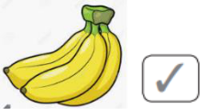

IV. Order the words.


Example: I/ two/ sandwiches./ have/


1. apple./ I/ an/ have/
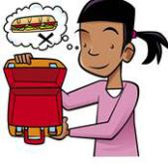

2. don’t/ have/ I/ sandwich./a


3. banana./ I/ a/ have/


4. cookies./ have/ I


5. | sandwich./ have/ I/ a/
 | have/ don’t/ an/ I/ orange juice.

Family & Friends 2 Special Edition

I ____________ a pizza.


I ____________ an egg.

___I have two sandwiches.___

__________________________

__________________________

__________________________

__________________________

__________________________

__________________________

Family & Friends 2 Special Edition

